SHADA Meeting 12 March 2018

Introductions:

Claire de Than, Chair of SHADA - Professor of Law
Helen Dunman, Vice Chair of SHADA - PSHE and sex and relationships education teacher, PMLD/SLD, Chailey Heritage Foundation
Dr Tuppy Owens – SHADA founder, Outsiders, TLC Trust, SHADA International, and the School of Sex for Disabled People
Jennie Williams – Founder and CEO of Enhance the UK – The Love Lounge and Undressing Disability campaign
Claire Holland – project manager and trainer from Enhance the UK
Gill Leno – Sex and relatiionships educator, writer and activist – Queen Alexandra College, SENSRE, and Supported Loving
Mary Doyle – Coach for disabled professionals, predominantly women; also writes for Liability
Asgerbo Persson– Handisex
Sue Newsome – Sex therapist and educator
Elliot Lamb – Occupational therapist and case manager for people with brain injury
Sally Lee – research fellow at Bournemouth University – social work background
Emma Cooper – LD and sexual health nurse and counsellor, supporting people post-autism diagnosis (with and without LD)
Jenn Layton - diagnosed 3 years ago with high functioning autism; here to talk about autism and sexuality – mentioned the participatory autistic research group
Tim Gilbert – Brain injury case manager with nursing background
Jesse Elvin – Lecturer in Law at City University
Chris Watling – Occupational therapist with community team for LD
Zaffron Hill – Education and Wellbeing specialist at Brook

Mary Doyle, Rocket Girl coaching – The Importance of Coaching

Mary’s background is technology and services, starting back in the 80s when she embarked on a programming apprenticeship that led to a full time role. After 28 years in software engineering with a job that allowed her to travel all over the world, she decided to change direction and retrained to coach others, using her experience as a female wheelchair user with CP in a series of senior roles in a male-dominated field. One of her passions is to normalise disability in the workforce and disabled sexuality.

Mary went on to talk about the ‘alchemy of coaching’. The definition of coaching is that it is a human development process that involves structured focused interaction, and use of appropriate strategies, tools and techniques, to promote desirable and sustainable change for the benefit of the coachee. It is measurable, tangible, and very practical. However, there is an element of intuition, human kindness, compassion wrapped up into that. It’s mostly forward looking.

She works with non-disabled people as well as disabled people, but seems to be taking more and more women clients on as they are being referred by word of mouth. She challenges the misconception that coaching is something that is targeted at low performers. Coaching is different to counselling because it’s more forward-facing and goal oriented; it’s to do with building strategy to get someone to where they want to be. She also explained that sometimes very high-functioning executive people will have a permanent coach, but more usually people will dip in and out of it, and that she is interested in making it accessible for everyone rather than an exclusive thing.

Mary works on success, goals and winning, on the terms of each individual client, working on what that really means for them. Tuppy asked Mary if her coaching relates specifically to sex, and Mary explained that very often sex and relationships are what her clients want to work on and bring to sessions, and that she supports people in using their differences to their advantage rather than seeing them as a limitation.

Mary went on to talk about the influence of the social and medical models on her work, noting that she has been very lucky personally to be able to incorporate into her coaching work. She uses her awareness of issues such as fatigue and disability to accentuate the work she does with her clients, to get the work as effective as possible. She is also currently training in neurodiversity so that she can work more effectively with neurodiverse clients.

Key themes –

- looking at individuals’ understanding of their own medical conditions and disabilities, and how their perceptions and awareness of these may impact on their successes, conditions and resilience
- Acquired disabilities and the consequent potential for grief and depression during and following the adjustment process
- People with military backgrounds who have been injured
- Clients who fear that they might not have sex again post-injury or trauma

She ended with a brief description of post-traumatic growth and how coaching supports and nurtures this, and how if this were more widely available on the school curriculum it could really make an impact on young people’s development.

Love and sex are an inoculation against everything that sucks! The more valuable someone feels, the better their decisions. Coaching can support confidence and hope. Mary wants to help inject joy into the every day.

Tuppy commented that there are more and more people with social anxiety joining Outsiders, and how coaching could be really supportive for them.

Jenn commented on how personal health budgets could potentially be used for supportive mental health interventions through coaching

Helen asked if there were any coaches who were working with people with more complex or severe learning disabilities/communication issues. Mary responded that most of her clients are in work, but that she will look into it – Helen talked a bit about meeting a severely disabled filmmaker at a conference and looking at doing some collaborative filmmaking with her students about dreams Jenny asked if there are any coaches using BSL – Mary is asking questions about this at the moment (about accessibility).

Lunch

Sex and relationships with Aspergers Syndrome

Jenn Layton
Claire opened by asking, ‘what mistakes do healthcare professionals make in their treatment of autistic women?’

Jenn responded that misdiagnosis is common, citing her own experience of misdiagnosis of borderline personality disorder, along with a lack of understanding and mishandling of issues such as autistic shutdown or meltdown.

Jenn talked about her own personal experiences of exploring and experimenting with her own gender and sexual expression. She reflected on the impact of her own late diagnosis of autism, in the context of a male-focused presentation of autism. She explained that autistic women are least like the expectation that society typically holds for them and that the coming to understanding of this can be catastrophic for mental health and wellbeing.

She went on to talk about the issues around communication (such as an inability to read body language) and sensory processing and the effects that this has within a neurotypical/neurodiverse relationship and on self esteem and wellbeing. There can be real incompatibilities which need a lot of work to overcome – Jenn explained that in Derbyshire, Relate has specialist counselling for couples with one neurodiverse partner.

There is a lack of information about how to support young adults in their late 20s – the community that was diagnosed 25 years ago – in their lives. Jenn reflected on the importance of autistic to autistic communication and support, and urged SHADA members to encourage their autistic clients to look at who they really are under the expectations that society has for them.

Jenn talked about the impact of a lack of empathy or social fear can be a difficult combination, because it reduces the ability to understand the impact of actions on others.

There are real issues for people who are autistic because of the issue of it being a deficit based, medically based diagnosis – what does that mean for those people about how they understand themselves? How does this then impact on formation of relationships? There needs to be support for positive risk taking – the inability to read intent and the tendency to be very trusting and take things literally means that young women with autism are terribly vulnerable to sexual abuse and potential exploitation.

What would the impact for someone on the spectrum be, particularly if that person was not very well supported or prepared?

Jenn finished by mentioning that there is a conference in Birmingham in May about neurodiversity, sexuality, and gender.

Tuppy Owens – supporting men with Aspergers to start relationships

Tuppy gave a presentation about her work to support men with Aspergers who had approached her for help through Outsiders – the presentation follows:

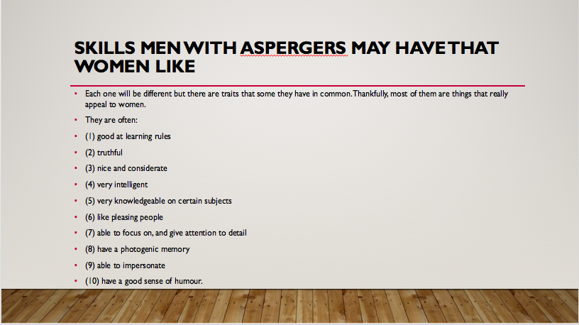

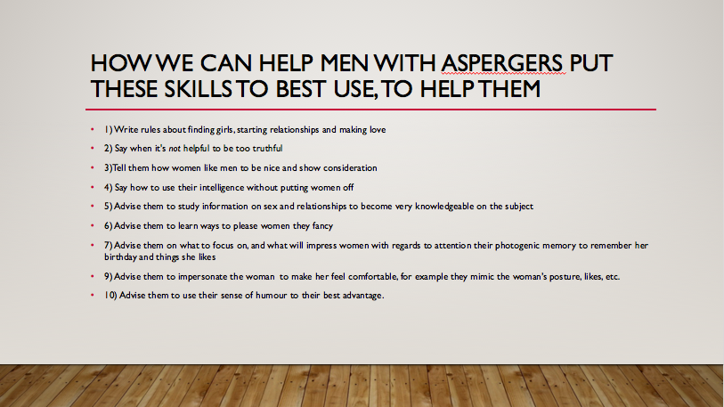

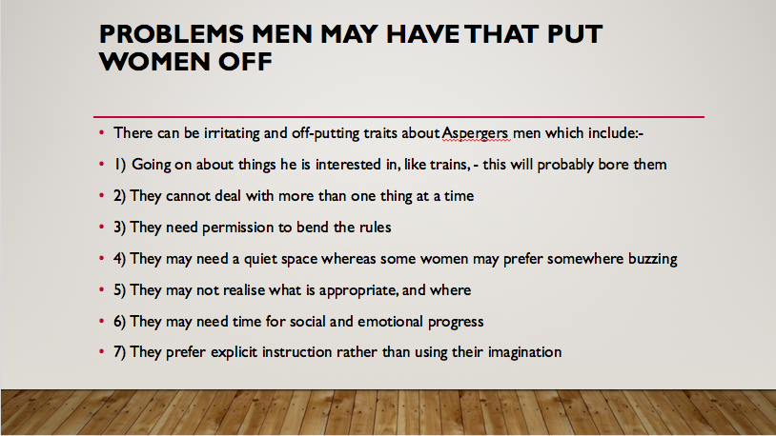

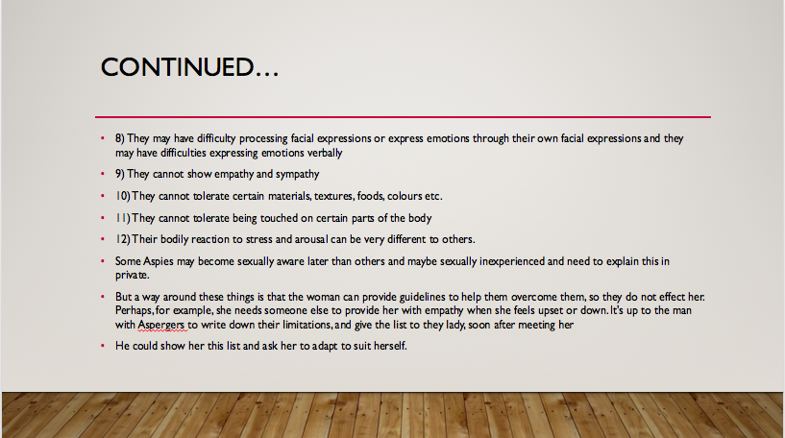

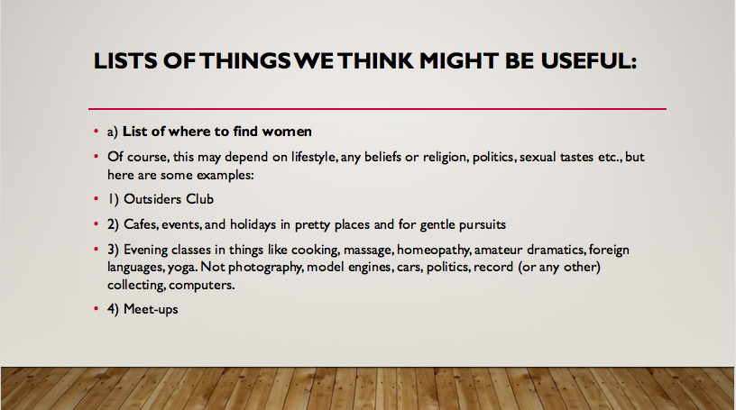

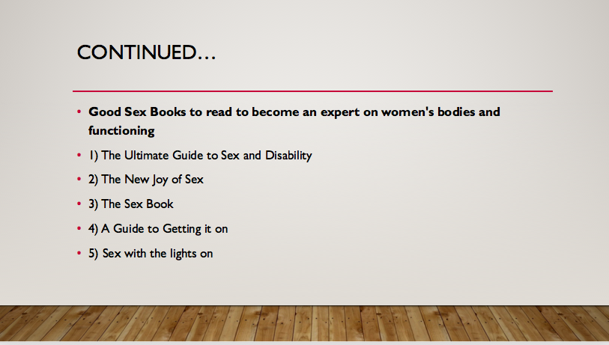

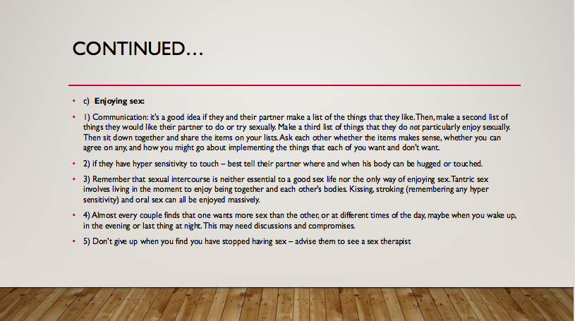

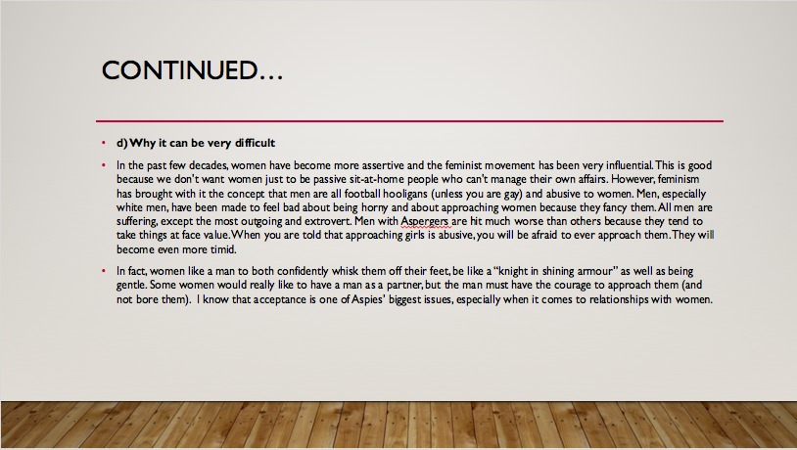

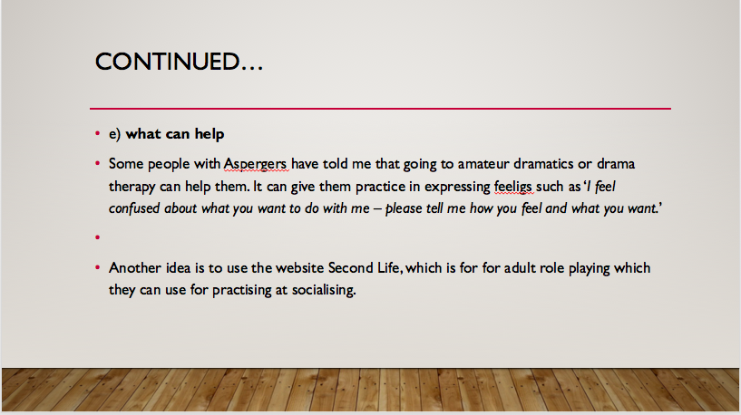

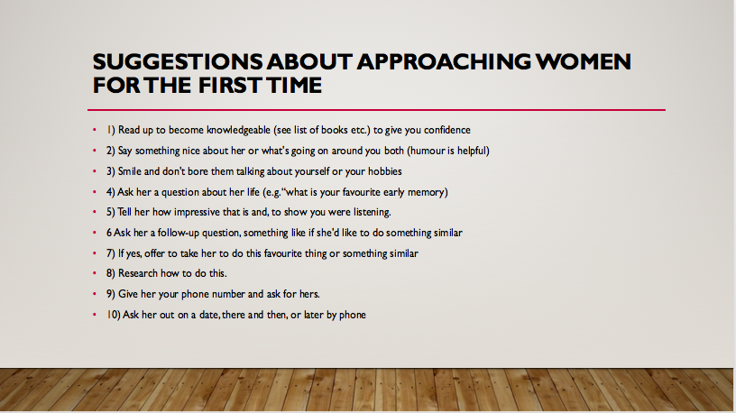

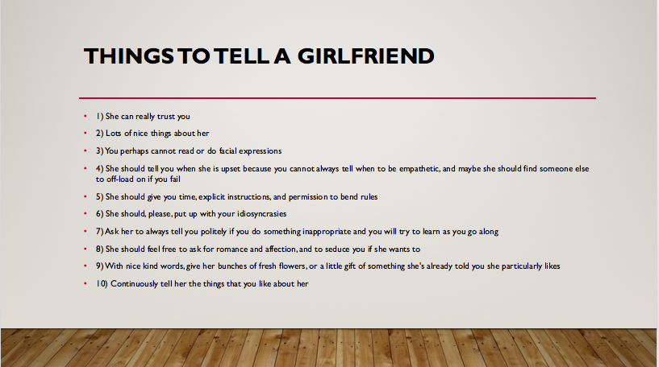

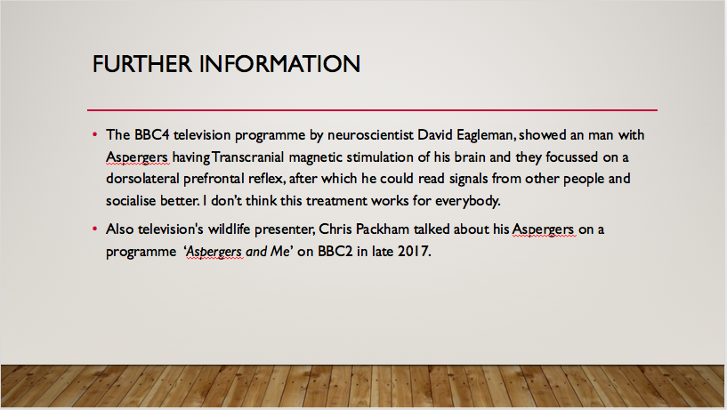

Sue Newsome

Sue shared some of her work with two clients who both identify as having Aspergers and explained that she would give some ideas of things that had and had not worked with those clients.

Client A had been diagnosed as a teenager and enjoyed support from his parents in finding additional help – the outcome of which was that he was living independently and had a good job. His father met Sue at a conference and came to ask her about his concerns about him being able to navigate more intimate relationships. He had arranged for his son to see a specialist who worked with Aspergers to assist him to learn social skills by rote to support him in managing himself in social situations, which he had taken to heart and had to some extent found successful, as he was socialising and had friends. The concern was that how he could take this forward to interact with potential sexual or intimate partners.

The client came to his first meeting with Sue with a female friend who he had known since he was very young. Sue determined that she would go forward by using a set of different exercises to support him, with his consent. Lots of work took place around grounding the conversation in the moment and in more successful interactions. Sue reflected that from a professional perspective, she felt that there would be the need to do lots of practice to allow social skills to be embedded.

Client B was a gentleman in his 40s who came via his psychologist who had recommended he had some sex therapy to support him, and who then referred him on to Sue for additional help. Sue arranged for a colleague who worked as a surrogate to provide support and they went on to do some work around meeting – space wise, proximity wise. His focus was very clearly on having a sexual experience rather than intimacy in a broader sense, and on going back to the sex therapist and psychologist it seemed that there was not going to be as much additional help for him from those professionals as he needed to integrate the potential experience with a sex surrogate. Because of this lack of support and continuity locally it was very difficult to continue with the work and Sue did not feel it was helpful for him to do so. He was referred to TLC.

Helen Dunman – Stories for sex education and puberty

Helen fed back about a training day that she had delivered in January. This happened after she’d had some visitors into one of her sex ed classes at school, and she was using dolls to support the session. The visitors asked her to come and provide a fun sex education day for all their teachers and teaching assistants. This was to be tied to targets and public and private, etc.

Helen has written a set of bespoke stories for her students around all sorts of issues such as periods, etc, which incorporate the use of dolls and props (including anatomy models) and very clear and simple language and common sense. Helen gave demonstrations of stories around topics such as periods, masturbation, safe touch, having a crush on someone, etc. She had some great feedback, including someone who said that they felt 100% more confident to teach these subjects – such a huge deal!

Helen stressed that although the stories and resources are simple to use, it is important that people are trained effectively in using them. This was backed up by the amount of feedback and discussion that was generated on the day.

Helen and Claire also fed back on a very successful conference that they ran about the law, disability, sex and sex education for Hertfordshire County Council, and the impact of the work that is being done. Helen talked about the feedback from parents about the effect of having good education for their children etc and how important it had been for them.

Helen is delivering another parent workshop tomorrow and is working with Claire on running another in the summer term, about dispelling myths about who can and cannot have a relationship, looking at capacity and intimacy.

Tuppy asked about whether there is any teaching of masturbation to female students – Helen responded that she’s written stories for male and female, it was just about the example that was being given. Tuppy suggested putting the stories online on the SHADA international website.

Claire commented that she had received some feedback from the Hertfordshire conference that some people at the conference had not even considered that young people with such complex learning needs who were nonverbal would even access sex education.

Discussion about body autonomy initiated by Jenn who noted the impact of not educating young nonverbal people at all about their body and their understanding of function and touch; Helen talked about how they are combating this at her school by looking at who can touch and when (ie, context), as well as raising visibility and understanding of one’s own body. Also talked about the importance of not doing risk focused sex education, ie only looking at the negatives. Also discussed private time and the importance of positive language and approach.

Mac McArthur – head of a special school in Swiss Cottage – is running a conference for £30pp called ‘Life Mapping’, focusing on sexuality and sex and relationships for disabled people. Professionals are invited to attend; Tuppy has put Helen and Emma (SHADA trustee) forward to talk at the meeting.

Asgerbo noted that there is a real issue if the expertise is not passed on.

AOB
Lorna Couldrick – will be retiring properly in July and hopes to come along to the next meeting – sends her best wishes to all!

Date for next meeting – Monday 12 November 11-4pm

Learning disabilities sub-group meeting – Monday 12 June

